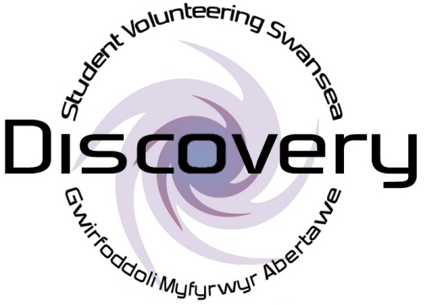

Discovery Volunteer Application Form

|  |  |
| --- | --- |
| MC900433953[1] | Name |
|  |  |

Address

MC900304819[1]

|  |  |
| --- | --- |
| BD18225_ | Telephone Number |
|  |  |

|  |  |
| --- | --- |
|  | Email Address |
|  |  |

|  |  |
| --- | --- |
| MC900188231[1] | Date of Birth |
|  |  |

|  |  |
| --- | --- |
| MC900232915[1]  MC900291025[1]  MC900232417[1]  MC900366482[1] | What are your hobbies and interests? |

What kind of volunteering are you interested in doing?

Office-based (e.g. photocopying, shredding, posting letters, making posters, greeting people, answering the phone, sending emails)

Project-based (e.g. planning activities, working with children, taking registers)

Would you prefer to volunteer one-to-one with a student or volunteer as part of a group?

**SUPPORT NEEDS**

|  |  |
| --- | --- |
|  | Do you have any disabilities?  Yes  No  What disabilities do you have?  Do you need any help to volunteer?  Yes  No  What help do you need so you can volunteer? |

Which days and times are you free to volunteer?

Please tick all the times you are free and we will find the best time together.

|  |  |  |
| --- | --- | --- |
|  | Morning | Afternoon |
| Monday |  |  |
| Tuesday |  |  |
| Wednesday |  |  |
| Thursday |  |  |
| Friday |  |  |
| Saturday |  |  |
| Sunday |  |  |

**DECLARATION**

I agree that Discovery will keep my application form safe and will not give it to anybody else. Discovery will only give my form to someone else if I say that is ok.

Signature:.....................................................

Date:...................................

When you have finished filling in this form, please return it to the following address:

Kirsty Rowles

Discovery Student Volunteering Swansea,

Fulton House,

Swansea University,

Singleton Park,

Swansea,

SA2 8PP