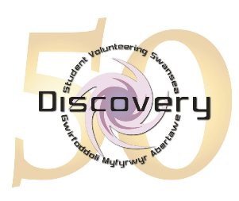

**Discovery Student Volunteering Swansea’s Annual General Meeting**

**9th of December 2020 6pm to 8pm, Zoom**

**Agenda**

1. Welcome and opening remarks by Jarren Coates, Student President.
2. Minutes of the 2019 AGM – Caitlin Jones (Secretary).
3. Celebration of the year’s achievements by Caitlin McCall (Student Vice President).
4. Vice Chancellor Paul Boyle.
5. Board of Trustees Report – Phil Brophy (Chair).
6. Finance report by Rachel Doyle of Gerald Thomas Accountants.
7. Adoption of annual accounts.
8. Appointment of auditors.
9. Presentation on Inspire – Megan Griffiths (Project Coordinator).
10. Presentation on the Supported Volunteer Scheme.
11. Candidate videos for portfolio student trustees.
12. Candidate videos for non-portfolio student trustees.
13. Reminder of how and where to vote.
14. Any other business.
15. 8pm Close.