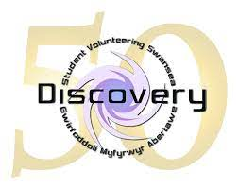

Guide to Trustee Elections
Every year you the Discovery volunteers get to vote for the trustee board. Trustees oversee the work of Discovery & have a meaningful say in the direction of Discovery and the impact it has on the local community so this is your chance to have a say in who should help run Discovery.
This year things will be a little bit different as the elections will be taking place online but we hope that this means that more of our volunteers are able to vote. This email will outline how you register to vote for the elections.
Voting for the student trustee positions starts today Monday 22nd November at 10am and voting will close on Monday 29th November at 9am.
We are fortunate that this year the Swansea Students Union are supporting Discovery by running the elections online for us. Below is how you get to register to vote in the elections. You must log in into the Swansea Students Union website as either a student (if you are a Swansea University student volunteer) or a Guest (if you are a Discovery volunteer who is not a Swansea University student). The trustee elections are called Discovery AGM Membership. We have outlined how to vote below:
To vote in the election right now just follow following steps:-
- Ensure you are logged in on the Students’ Union website
- Hover over ‘Student Voice’ to view the drop down menu
- Select ‘Elections’ on the drop down menu
- Select the ‘Discovery AGM 2021’ and proceed to vote in the election!
All Discovery volunteers get to vote for each of the positions which are:-
- Swansea University staff Trustee
- President
- Secretary
- Treasurer
- Non portfolio trustee
In each of the positions you will see this: Re-Open Nominations or 'RON. This is a democratic mechanism to allow voters to choose not to elect any of the candidates in the election. Basically if you do not want to vote for any of the candidates then vote for Re-Open Nominations.
If you have any issues around registering to vote please do let us know by emailing us.

Meet The Candidates

Swansea University Staff Trustee positions

6 candidates- 2 to be elected.

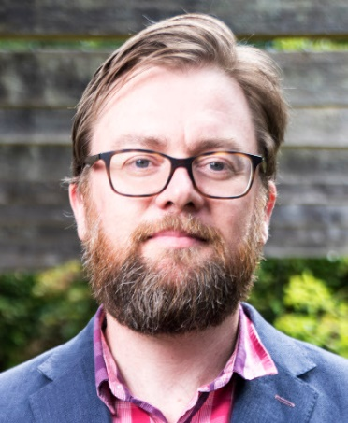
Andrew Kemp
By way of introduction, I am a Professor of Psychology at Swansea University and hold an Honorary Clinical Researcher role in the Community Brain Injury Service at Morriston Hospital.
Outside my university roles, I am involved in a variety of local clubs and societies including kickboxing and wing chun kung fu martial arts, which I enjoy practicing together with two daughters aged 13 and 11.
I am passionate about health and wellbeing and was the past director of research for the Health and Wellbeing Academy, during which time we secured a Guardian Award for Community and Societal Impact and a Swansea University Research and Innovation Award for outstanding impact on health and wellbeing. I have followed the work of the Discovery Charity with great interest over many years and regularly recommend volunteering opportunities to my students including mentees and third year students enrolled on PSY317 (Positive Psychology) . Martin Seligman, the so-called father of positive psychology has described volunteering as the single best way to improve wellbeing. Student (and staff) wellbeing is something that I am particularly passionate about. It is the focus of much of my research activity and my own experience of mentoring undergraduate and postgraduate students has revealed that student wellbeing is deteriorating, against a background of widely reported community disconnection and increasing loneliness. It was this observation that led me to develop my module on positive psychology and wellbeing science, and to encourage my students to explore volunteering opportunities offered by the Discovery Charity.
Critically, research shows that student wellbeing has been deteriorating even prior to the COVID pandemic, and this deterioration has worsened considerably over the last year and a half. I was therefore interested to see a recent blog post by the team at ‘What Works Wellbeing’ in which voluntary work (a social good) was the only ‘mental health promotion programme’ to notably impact on a commonly used measure of wellbeing, the Warwick Edinburgh Wellbeing Scale. Volunteering clearly provides a very important opportunity to significantly enhance the wellbeing of our staff and students at Swansea University and to contribute to building more positive and connected communities.
I am continually impressed by the range of volunteering opportunities that the charity provides to our students. I note with interest that Surfability is one of your partner organisations, which one of my PhD students has been working with to improve wellbeing in people living with acquired brain injury.
My research goals and those of the Discovery charity are clearly well aligned. If I were to be selected for this role, I would bring experience, commitment and passion relating to psychology, wellbeing and mentorship. If of interest, opportunities that I could potentially facilitate include data collection and research to help demonstrate the benefits of volunteering, and identifying additional projects, volunteers and community-based partners through my existing networks within and beyond Swansea University. Regardless, I am intrinsically motivated to support the student-led charity however that may evolve over the next few years if elected as non-student trustee.


Alison Walker
My name is Alison Walker and I am a lecturer in Adult Continuing Education in the School of Social Sciences.
I am interested in being a Trustee as I think that student volunteering is an important part of the university’s civic mission and would like to support its development. I work with non-traditional students, many of them studying off-campus in the community and so I appreciate the importance of partnerships with community organisations. One of my teaching and research areas is a pedagogy called service-learning which combines volunteering with academic credit to enhance students’ understanding of social justice issues and develop a graduate identity.
I am passionate about the power of student volunteering to benefit both the student and the community. I was a student volunteer myself, as an undergraduate, and have continued to volunteer through my life, with NACRO, Rape Crisis, Hospital Radio, Homestart and Cylch Meithrin Sgeti where I was the treasurer and a Trustee. I was also chair of the PTA. In my previous job, I ran two service-learning modules which involved working in partnership with over 30 third sector and public sector organisations, who inspired my research interest in social justice education.
I think I would bring to the role a strong understanding of social justice and the power of volunteering to have a positive impact on students and the communities they work with. On a practical level, I am experienced in leading teams with diverse backgrounds and enjoy working as part of a team to develop and maintain partnerships and opportunities. I am an experienced mentor and enjoy helping students to reach their potential in a range of situations. I hope that you will be interested in working with me and look forward to hearing from you.

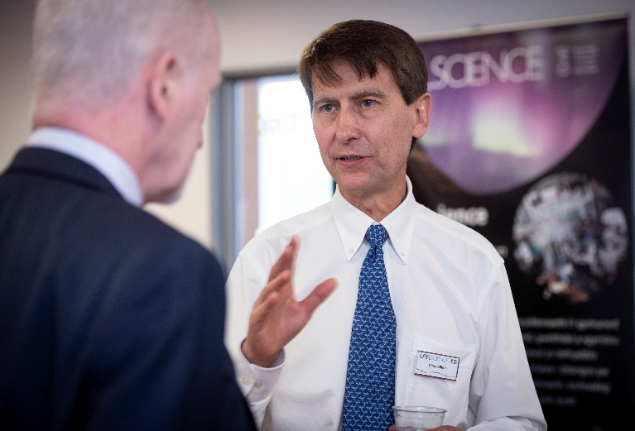
Chris Alton
The people I most respect are those who give up their time and energy to help others. I remember, when my children were younger, taking them to sports clubs and being extremely grateful to other parents giving their time to help coach a team of other people’s kids - my kids. I’m certainly not skilled in sports coaching. However, I do have some experience in committee work, running projects, and general management. For that reason I’m keen to use that “expertise” for the greater good.
The main “greater good” that lights my fire is social justice. Currently, a significant section of our society, through no fault of their own, is left behind, because they don’t have the same opportunities as the advantaged. Not only is this a personal tragedy for each individual concerned, but for society to disregard their skills and potential is a truly dumb way of running a country. What organisation would say to a third of its members “We’re just not going to really bother with you, no matter what you could offer us” ?
I am a Swansea University physics academic where I have been a member of staff for 25 years. During that time I have guided many hundreds of students in their education, supervised PhD students, and led research grants. I am the founder and Director of Oriel Science, a public engagement project which has engaged with 150,000 people since our Pop-Up centre was launched in 2016. We are very proud to have established a long-term city centre exhibition venue which opened in May this year. Amongst its exhibits is one from Discovery which showcases its Covid-related work. In the course of my work with Oriel Science, I have worked extensively with many stakeholders throughout the University and Community, and networked with local charities and the Government at city council and national level.
I’ve been aware of Discovery’s work and some of its projects for some time and have attended an AGM in the past. I am very aware that it is made up of people who give up their time and energy to help others. It would be a privilege to give some of my time and energy to help the charity’s mission by being a Trustee.

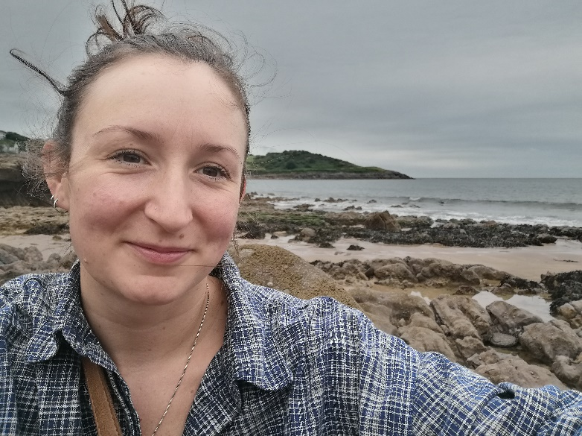
Helen Macrae
I have project management experience whilst working in a previous role as a Sustainability Coordinator and so am confident that I have transferrable knowledge and skills that I can share with regard to task management, budgeting, social media, and impact reporting.
My own philosophies align with the mix of staff and student Trustees, this again demonstrates that students have ownership and responsibility and I would imagine staff provide support and guidance as needed in a collaborative and equal way. I have experience similarly when Line Managing Higher Education Placements on their year in Industry, this for me looked more like a Mentorship role, guiding and supporting the students but enabling and empowering them to be decision makers and make the most of a variety of workplace experiences. Many of the volunteering activities, including work with children/young people and outdoor environmental hands-on initiatives is where lots of my past experience lies and so I feel that I could bring some valuable expertise in these areas.
Bringing to the role, Leadership and management experience, collaborative working/mentorship experience with Higher Education Students, project management and budget management experience, 9 years of teaching experience from Primary age to University age, positive, enthusiastic outlook, proactive, efficient, and creative working style, and first-hand experience of volunteering in different capacities and a true understanding of its powerful capability to boost career prospects and enrich the lives of all involved.
I have worked in Education for the last 8 years in various sectors. I had no idea however, what I wanted to do when I graduated and so made a list of all the volunteering opportunities locally that I could find. My first volunteering experience was with Cheshire Young Carers, I absolutely loved this experience. To gain experience for my PGCE application, I volunteered for 2 years with Cheshire Young Carers and worked voluntarily as classroom support one day a week whilst waitressing full time. Once qualified in 2013, I started out as a Primary School teacher working in Ellesmere Port near Chester and Liverpool. I worked in the mainstream classroom for almost 4 years before I moved into outdoor education in North Wales with the environmental education Charity Field Studies Council. I was teaching predominantly A-Level aged students in outdoor Biology and Geography Fieldwork skills. I moved back to South Wales to be closer to family just as the Covid-19 pandemic worsened in March 2020. I took on some temporary roles within Gower College Swansea as a Pastoral Coach and at Margam Park as Education Team Leader before starting with Swansea University in Academic Quality Services in April 2021.
I am thoroughly enjoying working within the University although this has all been from home so far! What I do miss however, is interacting with students! Although incredibly interesting, Quality Assurance is definitely a behind the scenes role in education and I want to engage with learners again in some capacity and the opportunity of Staff Trustee with Discovery SVS seems like a really good opportunity for this.

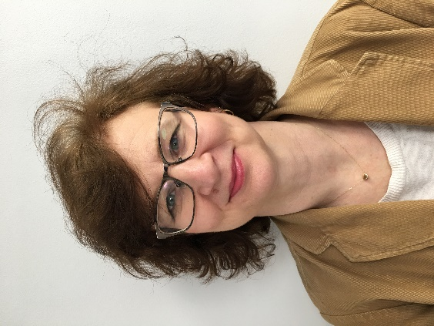
Louise Rees
As an undergraduate student I volunteered for ‘Swansea Community Action’; at that time, I was one of a group of students accompanying a number of young teenage children from Bonymaen to the then Leisure Centre on a Wednesday afternoon to swim. The opportunity was a way to connect with the local community, to add value to the young teens, deepen connections with my co-volunteers and to also grow my confidence.
In my personal life, I saw the need to connect with others and used my skills and expertise to provide online resources for children who attended our church, linking up with the Sketty Local Area Coordinator to apply for funds from the Greatest Need initiative, to put on online chat sessions and to be able to connect up with the local Food Bank and get my street involved in donating. I also have three sons, two of which are now first year undergraduates. They have volunteered in various guises in their teens and not just because they had to for the dreaded ‘Welsh Bacc’, but because my husband and I, along with youth leaders, have emphasised the great benefits that brings to both parties. So I have first hand experience in supporting and encouraging young people to seek out and reflect on their experience.
I have also been a trustee of a charity (2011- 2017). As deacon responsible for children's work at Pantygwydr Baptist Church I am familiar with the trustee obligations and requirements to deliver activities to support the mission and with responsibility for human resources and financial matters. I was the link deacon to the paid children’s worker, liaising between her and our ‘Board’ on how she was fulfilling needs or areas where she needed more support.
I have also been a volunteer myself for the Church leading or supporting children’s activities there for more than 13 years. I have therefore undergone regular training in safeguarding (completed the last one earlier in October 2021) and understand the issues involved in ensuring the safety of both clients supported and volunteers.
My professional knowledge as a member of Swansea Academy of Learning and Teaching and previously 15 years working in Academic Services means I have a wealth of experience in supporting and being a secretary at various University level committees and working groups and of supporting staff to teach online during the recent pandemic. I have been a key player in our social media presence for SALT, using Twitter extensively and also the Facebook Group (now Page) for the Church until September 2021 where other commitments have forced me to step back. My SALT role involves recruiting staff to ‘volunteer’ to support their colleagues; mentoring or coaching skills are integral to what I currently do and what I previously did as Head of the Quality Office in Academic Service (or Academic Registry as it was then known). I would apply these skills and experience to supporting the student trustees in the operation of the Charity and their personal growth.
Re-Open Nominations or 'RON. This is a democratic mechanism to allow voters to choose not to elect any of the candidates in the election. Basically if you do not want to vote for any of the candidates then vote for Re-Open Nominations.

Student Trustees – roles in order to be elected.
Those candidates that don’t get elected in officer roles to be put forward to non-portfolio roles
President 3 candidates- 1 to be elected

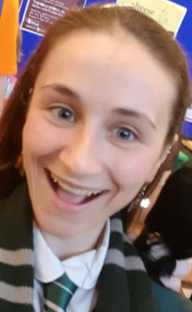

Felicity McKee
My name is Felicity McKee and I am running for both President and non portfolio student Trustee.
I have been a volunteer and project co-ordinator for Discovery for three years. I believe in the ethos of discovery and the work that it does and have spent the last year as a trustee to be able to get more involved in Discovery and to steer the direction of it.
As a project co-ordinator (PC) for Connect, I am one of three PCs for the project. I believe this has given be suitable skills to be able to work as a team with other portfolio trustees and running for President feels like a logical next step in my journey at Discovery.
I am interested in taking on further responsibility and to build upon my time as a trustee through working with the Chair of the Board of Trustees and the Manager to take the lead in planning and decision making around key issues. I also want to help build and progress the family style atmosphere of Discovery, especially amongst Trustees.
I currently organise and run sessions for my volunteers and want to expand to organising student trustee meetings and ensuring they are kept up to date with activities within the organisation.
I have experience on committees both regionally and nationally and believe I have the core skills to be able to chair a meeting and ensure that all points are covered, and everyone has the chance to speak.
I have developed leadership skills through my time as a Trustee (non-portfolio) running a sub committee as well as being a project co-ordinator for both Wellbeing Champions and Connect. Prior to this I’ve been running Look After Your Mate training for students to help them look after their mental health and emotional wellbeing and believe these are skills that show I can run and organise sessions such as BOT and AGMs.
I also have experience sitting on the National Union of Students disabled students committee as well as the regional NUS-USI disabled students committee and have achieved all of this while completing my undergrad, masters and now my PhD. I am able to multitask and regularly speak publicly at conferences both face to face and online as part of my work as a researcher. I believe I will be able to motivate and encourage others by leading by example and ensure everyone feels heard and engaged with their role as a trustee.

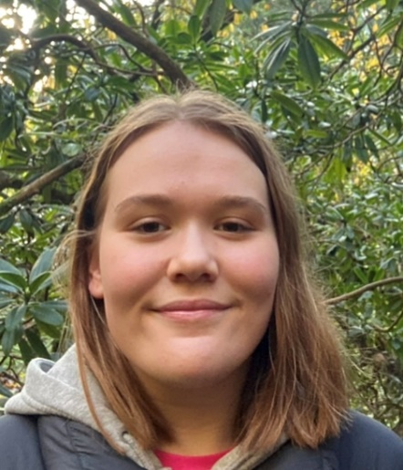

Ruby Thomas Collins
Hello there! My name’s Ruby and I’m running for the role of President and non-portfolio Trustee .
I believe that I’m strongly suited to the role because of my extensive legal background; as a postgraduate Law student at Swansea University, I am well equipped to comply with all the legal responsibilities of running a charity.
Pursuing a postgraduate degree requires dedication and diligence, both of which being qualities that I possess and would bring to this role. I have volunteered for Discovery across many different projects, so I have a good understanding of the charity and its ethos on a number of levels. I am currently the project coordinator of the Pen Pals project and have just concluded a 6-month internship at Discovery, dedicating over 150 hours of my time for the charity over the last year. Throughout my time in these roles, I have organised and managed teams of people and planned several events, so the notion of taking charge of projects is one that I am familiar and comfortable with.
If elected, my main aim as President is to help Discovery grow and reach far more students and members of the community. I first heard about Discovery in the final year of undergraduate degree, and I just wish that I would have found it earlier, as, throughout the last year, Discovery has become a very large part of my life.
Discovering the charity in the midst of a global pandemic helped tremendously because, like many other students, I found the lockdown periods to be mentally challenging. Not being able to engage in the usual ‘pros’ of university, such as socialising and interacting with fellow students, on top of the increased academic workload that comes with the final year of study, made much of that time feel isolated and lonely. Discovery provided me with a purpose, a chance to meet brilliant new people and an outlet that didn’t entail university work. Discovery has provided me with so many wonderful opportunities, such as my internship and the chance to become a project coordinator. Because of this, I would love to help Discovery develop and grow throughout my time as a trustee because I want to make sure that many more people benefit from it, just as I benefitted.
I want to make sure that everyone can get as much as they can out of volunteering because I believe that it is one of the most rewarding things you can do – not just for the people you support, but also for yourself.
If you vote for me, I promise to be your voice and to make sure that you are fully supported throughout your time volunteering with Discovery. I am not one to shy away from raising difficult issues to those in charge so you can be assured that anything you want me to raise, will be raised -- no matter how big or small the issue may seem.
It would be an absolute privilege to represent Discovery as your President.
- Re-Open Nominations or 'RON. This is a democratic mechanism to allow voters to choose not to elect any of the candidates in the election. Basically if you do not want to vote for any of the candidates then vote for Re-Open Nominations.

Secretary 3 candidates- 1 to be elected


- Natalie Jarvis
Hi I am Nat Jarvis and I am standing to for Secretary of Discovery and non portfolio Trustee.
I became a Discovery volunteer last year and since then I have become the project coordinator for the digital media project. I have clocked up over 130 hours and I am always excited to see what project I can get myself involved in next.
Taking on the PC role has excelled my confidence in my organisational skills, and I believe I can conduct the secretary duties with ease. I have good communication skills both in a professional and social setting and love having a chat! I can type pretty fast and feel I would be able to keep up with the face of recording minute meetings without feeling overwhelmed. I enjoy order, lists and overall organisation which makes me the perfect candidate for this role.
I have a clear passion for Discovery and everything it does for the local community. I believe that our projects really are making a difference to hundreds of people who need it most in our communities and I am dedicated to ensuring that this amazing work continues to happen.
I really would love the chance at a new challenge, and I am always keen to learn new things, I adapt to fast paced environments and work well under pressure. I am an individual who likes to be kept busy, I like my diary to be jammed packed with things to do and there is nothing I love more than ticking off something on my days to do list.
I was born in Neath Port Talbot the neighbouring village to Swansea, and I have spent 5 years at Swansea University. I have lived in the area, so has my daughter, so do loads of my family and friends. The fact that Discovery conducts work that really does help the community that I live in, and love makes me feel like all the work I do for the charity is worthwhile and like I really can make a difference to those people whose lives need it the most.
I have come from an unprivileged background and completely understand what it is to be in difficult circumstances, I have been in situations where I have had to rely on food banks, emergency housing hostels and many darker places. I realise just how lucky I am to have escaped these bad times and I am in a really good position with a nice cosy warm home, a good education and plenty of career options. I acknowledge that there are a large proportion of people in Swansea and South Wales in general living with less life quality than myself and how important it is to help these people when they need it most. I will always do everything in my power to ensure that Discovery continues to work to make our communities a better place for
everyone.


- Freya Michaud
My name is Freya Michaud and I am standing to be secretary and non portfolio Trustee.
I was selected to be the Learning and Teaching Representative for Cardiff Business School’s new Shadow Management Board in 2015. I was in charge of monitoring communications and enterprise activities. This contributed to the establishment of a Communications Network in the Business School and the School becoming involved with Enactus to promote social responsible enterprises. This tied in with my work on advising on the School’s new Public Value strategy which was launched in 2016.
I was a member of the University’s Staff Time to Change network and the Working Group. We recently resigned the pledge and re-launched in February and I am liaised with colleagues in Equality and Diversity, Staff Wellbeing, HR and student volunteers and formulated a programme of events to engage staff and students in the launch and raise awareness of the destigmatisation of mental health in the University. I represented the Head of Counselling, Health and Wellbeing on the Equality & Diversity Committee for 2016/17, as he was unable to attend on each occasion. I was the Equality and Diversity contact for Counselling, Health and Wellbeing and attended and contributed to the Equality & Diversity contacts meetings. I have completed Equality & Diversity training from HR.
I was secretary to 3 Boards of Studies which met twice per semester. I took all minutes, collated and circulated papers, as well as managing all communications with committee members. I ensured all documents and communications were completed in a timely manner and in the required format.
I coordinated 12 student staff panels, which involved recruiting and training student representatives, scheduling meetings and finding rooms and circulating all communications. I prepared the minutes from the meetings to be presented at the relevant Boards of Studies meetings and ensured the Student Representatives attended.
I was the Project Administrator for PATH training for Cymorth Cymru. Cymorth Cymru is the umbrella body for providers of homelessness, housing-related support and social care services in Wales. This training was funded by the Welsh Government and aims to support the prevention of homelessness through trauma-informed approaches to meeting people's housing and support needs. I loved working in a charity and being involved in the admin behind helping people. It really made me feel like I was making a difference and I found it really interesting learning how the mechanisms of a charity worked.
I spent three days volunteering for Care4Calais in December 2018, helping out in a warehouse in Calais and distributing goods and services to refugees in the surrounding area. This is something I had wanted to do for a long time and it was an eye opening and life changing experience. Seeing how the operations of the charity were run, I saw that my previous skills and experience would be exceedingly relevant and transferable. Having worked with vulnerable people in a Counselling Service, taught refugees in a language college and having a wide range of experience in administration and operations.
- Re-Open Nominations or 'RON. This is a democratic mechanism to allow voters to choose not to elect any of the candidates in the election. Basically if you do not want to vote for any of the candidates then vote for Re-Open Nominations.

Treasurer 2 candidates- 1 to be elected


- Devarshi Raval
My name is Devarshi Raval and I am running for Treasurer and non-portfolio Trustee. Being part of Discovery this past year as a trustee, chair of fundraising and finance, as well as an active volunteer has given me a sense of fulfilment and leadership at such a young age, that many people my age wouldn’t get to experience.
Through working with the board of trustees, organising fundraising ideas and projects, and simply taking part in beach litter pick-ups and through ELTS, I understand and love how the charity works, and its purpose to make a real difference in the community. It can be really fulfilling to see everything in action and the real-world impact of your own work, especially since I share the same set of values and ethos of the charity and assisting Discovery to fulfil its purpose and continue to grow and develop.
Coming from a background in corporate governance and law, and finance, I have really enjoyed this level of leadership and gained such effective managerial professional skills. Reapplying and standing for treasurer this year, comes to me naturally as I can expand my role and responsibilities in Discovery and become more involved with the finance, fundraising, and the legal responsibilities that come with it.
I already have background in the funding situation at Discovery. My employability history, and my responsibilities within my family business and at Mango Marketing and events shows that I can successfully fulfil my role as treasurer, as I already have experience of dealing with accounts and financial reports, monitoring business’s performance against budgets, project spending and key outcomes. In my family business, in particular, my responsibilities include inventory checks, looking at the expenses, keeping track on the cashflow, and using excel spreadsheets.
In 2021, charity boards remain less diverse than the FTSE 100, just 36% of trustees being women and 8% are people of colour. Personally being an Asian female student and the Co-president of Swansea Asian Society, diversity and inclusion is very important to me and supporting a charity like Discovery, that champions diversity at all levels is very vital, and one of the reasons why I feel so connected to Discovery.
I have always been passionate about volunteering and sewa, and this can be seen through my previous employment and volunteering experiences. I am an excellent team player and mentor, and have taken several leadership roles through my education, such as Head of House in sixth form, Co-President of Asian society, general secretary of both Indian and Economics societies at Swansea University and the 2nd year Economics student rep. All of these roles have shown me that teamwork is a big asset to any company or organization to enable growth and progress and I hope I can use this to continue contributing effectively to my team at Discovery.
I enjoy making new connections, feel satisfied knowing I’ve made a difference to other people’s lives, and help them grow to their full potential. My communication, interpersonal skills and professional experiences all indicate that I can work with diverse set of people, which is important to be part of Discovery and my role as Treasurer.

- Re-Open Nominations or 'RON. This is a democratic mechanism to allow voters to choose not to elect any of the candidates in the election. Basically if you do not want to vote for any of the candidates then vote for Re-Open Nominations.

Non Portfolio 10 candidates- 6 to be elected

Samuel Yeng
- Samuel Yeng

My name is Kwan On Samuel Yeung, studying Mechanical engineering, and I am standing to be a non portfolio Trustee of Discovery.
I used to be a trustee of Church’s Charity for 2 years back in my home country. I used to organising events like: monthly visiting and cleaning for single living elderly; annual charity fund raising walk. However, I never experienced any charity and volunteering work in the U.K. and other country. This year, I would like to challenge myself, participating and taking duties in Charity organisation. And I think Discovery Student Volunteering Swansea is a great opportunity for me to get myself involving volunteering and charity role. Also, getting myself involve into the local community, to understand and experience the local culture, social needs and local difficulties. I worked as a Marketing assistant intern in 2018-2019, I am experienced with content create, graphic design, photography, videography, organise events and public speaking. I was also Marketing Officer of Swansea University Fencing Club (2018,2019,2020) and Swansea University Hong Kong Society (2018-2019). I am experienced in organising fresher; social; training events and content create. I hope that my experience and skills can help and benefit to Discovery SVS. My aim of apply the role (Trustee) in Discovery SVS, is to challenge myself, serving the local community, experience and understand the local culture and difficulties. I hope that I will learn, gain experience and self improve from this role (Trustee in Discovery SVS).


- Nomonde Joya

Hi my name is Nomonde Joye and I am a Msc Management (International Management) student standing to be a non portfolio Trustee.
While I will stand to benefit great experience in my area of interest which is connected to my studies, I do believe that I too will offer the board and Discovery my creating inputs and compassion as I fulfil my duties. I have not been connected to a formal organisation for volunteering before, however, as I live in a community of people, I have previously been involved in positively impacting the community I am part of. Growing up in South Africa, part of informal settlement living due to past segregation laws in the country. Many people around me did not have much to go by, children play in the streets often unsupervised as parents are away trying to earn a living. In the holiday’s when I get a chance to visit where I come from, I tended to gather young kids over a period of two weeks at times and have a daily program of dance, play and talk on life. Also, I spend 10 months from the onset of the pandemic working in Covid facilities, first at an emergency hospital set up for excess capacity, then at a Covid test centre from when they got introduced in the middle of last year, leading up to January when my studies began. Although I was getting paid, it was tough navigating with so much uncertainly, yet I was constantly putting myself out there to make a different in the community how I could.
For over 5 years, I worked in the hospitality industry. Providing customer service in a world-renowned conference centre (Excel Exhibition Centre), where people where hosted from all parts of the world. The diverse customers I encountered enabled me to develop my interpersonal skills together. I did leave the role as a team leader, which meant I was responsible for up to 8 staff members at a time. Ensuring health and safety measures are adhered to as well as delivering a great customer service and placing equal amount of care to each customer. This was one of the value propositions of the company, winning one customer at a time. As a team leader I was also responsible for carrying out the directives of my managers and providing support in other teams or unsupervised self-service stations.
I am always willing to learn and develop in order to better myself and those around me. Being a trustee at discovery would be an amazing opportunity for me to develop my strategic thinking and applications as I am currently undertaking an International Management Masters with a key interest in strategy and leadership(management). My care in having a positive impact, creativity and compassion for others will enable me to adequately apply myself to the role for the greater good of those who stand to benefit from the amazing work of the charity. Hence, it would be my humble honour to offer my services and beyond to the team as I too learn and grow, with the inherent pleasure of giving back.

- Devarshi Raval

My name is Devarshi Raval and I am running for Treasurer and non-portfolio Trustee. Being part of Discovery this past year as a trustee, chair of fundraising and finance, as well as an active volunteer has given me a sense of fulfilment and leadership at such a young age, that many people my age wouldn’t get to experience.
Through working with the board of trustees, organising fundraising ideas and projects, and simply taking part in beach litter pick-ups and through ELTS, I understand and love how the charity works, and its purpose to make a real difference in the community. It can be really fulfilling to see everything in action and the real-world impact of your own work, especially since I share the same set of values and ethos of the charity and assisting Discovery to fulfil its purpose and continue to grow and develop.
Coming from a background in corporate governance and law, and finance, I have really enjoyed this level of leadership and gained such effective managerial professional skills. Reapplying and standing for treasurer this year, comes to me naturally as I can expand my role and responsibilities in Discovery and become more involved with the finance, fundraising, and the legal responsibilities that come with it.
I already have background in the funding situation at Discovery. My employability history, and my responsibilities within my family business and at Mango Marketing and events shows that I can successfully fulfil my role as treasurer, as I already have experience of dealing with accounts and financial reports, monitoring business’s performance against budgets, project spending and key outcomes. In my family business, in particular, my responsibilities include inventory checks, looking at the expenses, keeping track on the cashflow, and using excel spreadsheets.
In 2021, charity boards remain less diverse than the FTSE 100, just 36% of trustees being women and 8% are people of colour. Personally being an Asian female student and the Co-president of Swansea Asian Society, diversity and inclusion is very important to me and supporting a charity like Discovery, that champions diversity at all levels is very vital, and one of the reasons why I feel so connected to Discovery.
I have always been passionate about volunteering and sewa, and this can be seen through my previous employment and volunteering experiences. I am an excellent team player and mentor, and have taken several leadership roles through my education, such as Head of House in sixth form, Co-President of Asian society, general secretary of both Indian and Economics societies at Swansea University and the 2nd year Economics student rep. All of these roles have shown me that teamwork is a big asset to any company or organization to enable growth and progress and I hope I can use this to continue contributing effectively to my team at Discovery.
I enjoy making new connections, feel satisfied knowing I’ve made a difference to other people’s lives, and help them grow to their full potential. My communication, interpersonal skills and professional experiences all indicate that I can work with
diverse set of people, which is important to be part of Discovery and my role as Treasurer.


- Emma Burton

Hi I am Emma Burton and I am standing to be a non portfolio Trustee.
I have had a truly amazing year as Discovery Student President, 2 years as a trustee and 3 years as a volunteer with Discovery. This year we have accomplished so much as a team through the pandemic, and I would like to continue to assist the charity in the recovery following lockdown and support the new and returning staff to help get the charity back up and running as usual. I think it’s important to have someone on the student board with first-hand experience and I still have a lot of new ideas to help develop the charity. As the current student president, I would like to be there to support, advice and encourage the next board of trustees as I know how difficult it can be and want to share the knowledge and tips I have acquired.
It is my 4th year with Discovery, and I have been every role, from service user to project coordinator, to intern and ambassador, so I know the charity like the back of my hand and know what works well and what could be improved. I know the current plans that the current trustees have made and would like to help to see them through and put them in place in the next year to modernise and improve Discovery, while also ensuring we are meeting our core visions and aims. I am extremely reliable, organised, and approachable and am always there when needed, whether it be to support staff, run volunteering sessions, help with publicity or simply be a friend for a volunteer who needs it. I have created systems and strategies to keep the board organised and make information accessible that I would like to share and improve with the next trustees.
This year I would like to focus on wellbeing of staff members, students and service users following covid-19 and how to ensure the day to day running of Discovery is as safe and accessible as possible to allow us to resume face to face volunteering and making a positive impact on service users and community. I also want to encourage the continuation of virtual volunteering as I think this is an excellent way for people who are not in Swansea or cannot make it to events to get involved, and it improves accessibility to service users and volunteers significantly. I am one of the few language students who is involved in Discovery, and I would like to encourage more students and staff of this department to volunteer by running department events and presentations, especially during induction.
I have gained so much confidence, various skills, and incredible experiences during my time as a volunteer and a trustee and I want to carry on being a friendly and helpful face on the board. After volunteering since the moment I arrived at university, I want to spend my final year the same way I started- with my Discovery family!

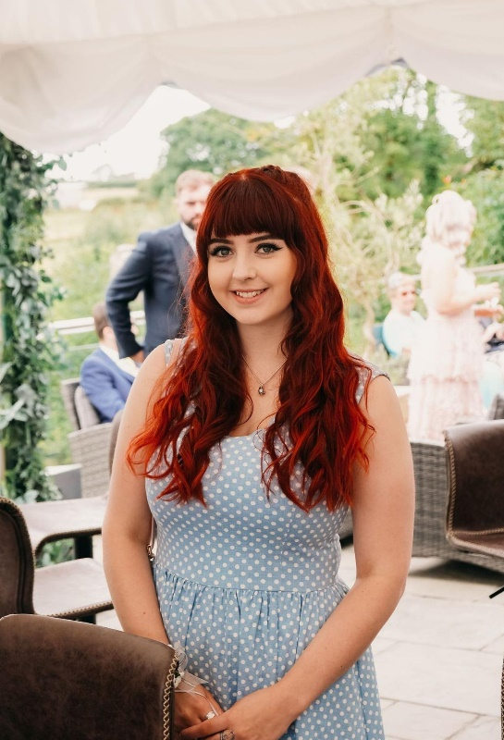
- Georgia Rees
My name is Georgia Rees and I am standing for non portfolio Trustee.
I am interested in the role of trustee as I love volunteering and would like to expand my knowledge on how charities operate. I am a hardworking individual and would therefore bring a lot of enthusiasm and dedication to the role. I have been working part-time alongside my degree to develop my teamwork, communication and problem-solving skills, which I believe could be further developed within this role. I have been a Discovery volunteer for over a year, particularly engaging with the CoronaDiaries and PenPal projects, and more recently, I have become a Discovery Ambassador, which has provided me with a good knowledge of the charity and the current projects that are running. I am originally from Swansea and many of my personal morals align with Discovery’s, which is why I’m very passionate about the work that Discovery does for my local community, and why I’m interested in being more involved with the organisation. In the future, I would like to become a youth or family support worker, meaning I would be working closely with charities and organisations that support vulnerable individuals. Therefore, I believe that becoming a trustee for Discovery would provide me with transferable skills and in-depth knowledge that I can use throughout my career. I feel rewarded and inspired knowing that I can make a positive impact on my local community and would like to increase my responsibility and influence in this area, as well as developing leadership skills. I dedicate a lot of time to my work, to ensure it is of good quality, and I am devoted to providing an inclusive and supportive environment for the staff and students I work alongside, as well as the service users accessing the projects. I have great attention to detail and I’m always eager to provide the best possible experience for those I am working with. I think it’s an incredible opportunity to become a trustee whilst completing my university degree, and one that will help me become more employable when I’m looking for graduate level jobs. Thank you for your consideration.

- Natalie Jarvis
Hi I am Nat Jarvis and I am standing to for Secretary of Discovery and non portfolio Trustee.
I became a Discovery volunteer last year and since then I have become the project coordinator for the digital media project. I have clocked up over 130 hours and I am always excited to see what project I can get myself involved in next.
Taking on the PC role has excelled my confidence in my organisational skills, and I believe I can conduct the secretary duties with ease. I have good communication skills both in a professional and social setting and love having a chat! I can type pretty fast and feel I would be able to keep up with the face of recording minute meetings without feeling overwhelmed. I enjoy order, lists and overall organisation which makes me the perfect candidate for this role.
I have a clear passion for Discovery and everything it does for the local community. I believe that our projects really are making a difference to hundreds of people who need it most in our communities and I am dedicated to ensuring that this amazing work continues to happen.
I really would love the chance at a new challenge, and I am always keen to learn new things, I adapt to fast paced environments and work well under pressure. I am an individual who likes to be kept busy, I like my diary to be jammed packed with things to do and there is nothing I love more than ticking off something on my days to do list.
I was born in Neath Port Talbot the neighbouring village to Swansea, and I have spent 5 years at Swansea University. I have lived in the area, so has my daughter, so do loads of my family and friends. The fact that Discovery conducts work that really does help the community that I live in, and love makes me feel like all the work I do for the charity is worthwhile and like I really can make a difference to those people whose lives need it the most.
I have come from an unprivileged background and completely understand what it is to be in difficult circumstances, I have been in situations where I have had to rely on food banks, emergency housing hostels and many darker places. I realise just how lucky I am to have escaped these bad times and I am in a really good position with a nice cosy warm home, a good education and plenty of career options. I acknowledge that there are a large proportion of people in Swansea and South Wales in general living with less life quality than myself and how important it is to help these people when they need it most. I will always do everything in my power to ensure that Discovery continues to work to make our communities a better place for everyone.

- Freya Michaud

My name is Freya Michaud and I am standing to be secretary and non portfolio Trustee.
I was selected to be the Learning and Teaching Representative for Cardiff Business School’s new Shadow Management Board in 2015. I was in charge of monitoring communications and enterprise activities. This contributed to the establishment of a Communications Network in the Business School and the School becoming involved with Enactus to promote social responsible enterprises. This tied in with my work on advising on the School’s new Public Value strategy which was launched in 2016.
I was a member of the University’s Staff Time to Change network and the Working Group. We recently resigned the pledge and re-launched in February and I am liaised with colleagues in Equality and Diversity, Staff Wellbeing, HR and student volunteers and formulated a programme of events to engage staff and students in the launch and raise awareness of the destigmatisation of mental health in the University. I represented the Head of Counselling, Health and Wellbeing on the Equality & Diversity Committee for 2016/17, as he was unable to attend on each occasion. I was the Equality and Diversity contact for Counselling, Health and Wellbeing and attended and contributed to the Equality & Diversity contacts meetings. I have completed Equality & Diversity training from HR.
I was secretary to 3 Boards of Studies which met twice per semester. I took all minutes, collated and circulated papers, as well as managing all communications with committee members. I ensured all documents and communications were completed in a timely manner and in the required format.
I coordinated 12 student staff panels, which involved recruiting and training student representatives, scheduling meetings and finding rooms and circulating all communications. I prepared the minutes from the meetings to be presented at the relevant Boards of Studies meetings and ensured the Student Representatives attended.
I was the Project Administrator for PATH training for Cymorth Cymru. Cymorth Cymru is the umbrella body for providers of homelessness, housing-related support and social care services in Wales. This training was funded by the Welsh Government and aims to support the prevention of homelessness through trauma-informed approaches to meeting people's housing and support needs. I loved working in a charity and being involved in the admin behind helping people. It really made me feel like I was making a difference and I found it really interesting learning how the mechanisms of a charity worked.
I spent three days volunteering for Care4Calais in December 2018, helping out in a warehouse in Calais and distributing goods and services to refugees in the surrounding area. This is something I had wanted to do for a long time and it was an eye opening and life changing experience. Seeing how the operations of the charity were run, I saw that my previous skills and experience would be exceedingly relevant and transferable. Having worked with vulnerable people in a Counselling
Service, taught refugees in a language college and having a wide range of experience in administration and operations

- Felicity McKee

My name is Felicity McKee and I am running for both President and non portfolio student Trustee.
I have been a volunteer and project co-ordinator for Discovery for three years. I believe in the ethos of discovery and the work that it does and have spent the last year as a trustee to be able to get more involved in Discovery and to steer the direction of it.
As a project co-ordinator (PC) for Connect, I am one of three PCs for the project. I believe this has given be suitable skills to be able to work as a team with other portfolio trustees and running for President feels like a logical next step in my journey at Discovery.
I am interested in taking on further responsibility and to build upon my time as a trustee through working with the Chair of the Board of Trustees and the Manager to take the lead in planning and decision making around key issues. I also want to help build and progress the family style atmosphere of Discovery, especially amongst Trustees.
I currently organise and run sessions for my volunteers and want to expand to organising student trustee meetings and ensuring they are kept up to date with activities within the organisation.
I have experience on committees both regionally and nationally and believe I have the core skills to be able to chair a meeting and ensure that all points are covered, and everyone has the chance to speak.
I have developed leadership skills through my time as a Trustee (non-portfolio) running a sub committee as well as being a project co-ordinator for both Wellbeing Champions and Connect. Prior to this I’ve been running Look After Your Mate training for students to help them look after their mental health and emotional wellbeing and believe these are skills that show I can run and organise sessions such as BOT and AGMs.
I also have experience sitting on the National Union of Students disabled students committee as well as the regional NUS-USI disabled students committee and have achieved all of this while completing my undergrad, masters and now my PhD. I am able to multitask and regularly speak publicly at conferences both face to face and online as part of my work as a researcher. I believe I will be able to motivate and encourage others by leading by example and ensure everyone feels heard and engaged with their role as a trustee.

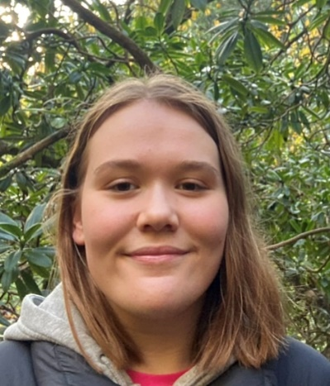
- Ruby Thomas Collins
Hello there! My name’s Ruby and I’m running for the role of President and non-portfolio Trustee .
I believe that I’m strongly suited to the role because of my extensive legal background; as a postgraduate Law student at Swansea University, I am well equipped to comply with all the legal responsibilities of running a charity.
Pursuing a postgraduate degree requires dedication and diligence, both of which being qualities that I possess and would bring to this role. I have volunteered for Discovery across many different projects, so I have a good understanding of the charity and its ethos on a number of levels. I am currently the project coordinator of the Pen Pals project and have just concluded a 6-month internship at Discovery, dedicating over 150 hours of my time for the charity over the last year. Throughout my time in these roles, I have organised and managed teams of people and planned several events, so the notion of taking charge of projects is one that I am familiar and comfortable with.
If elected, my main aim as President is to help Discovery grow and reach far more students and members of the community. I first heard about Discovery in the final year of undergraduate degree, and I just wish that I would have found it earlier, as, throughout the last year, Discovery has become a very large part of my life.
Discovering the charity in the midst of a global pandemic helped tremendously because, like many other students, I found the lockdown periods to be mentally challenging. Not being able to engage in the usual ‘pros’ of university, such as socialising and interacting with fellow students, on top of the increased academic workload that comes with the final year of study, made much of that time feel isolated and lonely. Discovery provided me with a purpose, a chance to meet brilliant new people and an outlet that didn’t entail university work. Discovery has provided me with so many wonderful opportunities, such as my internship and the chance to become a project coordinator. Because of this, I would love to help Discovery develop and grow throughout my time as a trustee because I want to make sure that many more people benefit from it, just as I benefitted.
I want to make sure that everyone can get as much as they can out of volunteering because I believe that it is one of the most rewarding things you can do – not just for the people you support, but also for yourself.
If you vote for me, I promise to be your voice and to make sure that you are fully supported throughout your time volunteering with Discovery. I am not one to shy away from raising difficult issues to those in charge so you can be assured that anything you want me to raise, will be raised -- no matter how big or small the issue may seem.
It would be an absolute privilege to represent Discovery.
- Re-Open Nominations or 'RON. This is a democratic mechanism to allow voters to choose not to elect any of the candidates in the election. Basically if you do not want to vote for any of the candidates then vote for Re-Open Nominations.

